

**Objectives:**

* Recognize keywords, identifiers, literals, and operators in the source code
* Handle whitespace and comments gracefully
* Generate error tokens/messages for duplicate variables
* Optimize regular expressions for improved lexer performance
* Provide clear and informative error messages
* Implement Loops
* Implement Conditionals
* Implement Functions

**Introduction:**

Flex and Bison are powerful tools in the realm of compiler construction, aiding developers in the creation of lexers and parsers. Flex, the fast lexical analyzer generator, excels in recognizing patterns in input, while Bison, the parser generator, is adept at parsing the structure defined by a context-free grammar. Together, they form a dynamic duo for processing and interpreting the syntax of programming languages or structured input. This report delves into the implementation and integration of Flex and Bison in a project aimed at parsing and analyzing a new syntax-based programming language. Through this exploration, we aim to showcase the effectiveness of these tools in constructing robust and efficient language processors.

**ID and Type Design:**

Datatypes:

datatype int | float | string

void void (Only used as a function prefix)

Type Design:

Int "-"?{digits}+

Float "-"?({digits}+)?"."{digits}+

String "\""[^"]*"\""

Identifiers [a-zA-Z][a-zA-Z0-9]*

**Headers:**

Import Prefix "#include"

Main Style {Identifiers}".h"

**Loops:**

* while similar to while loop

while (conditions) {statements}

* for similar to for loop

for (initialization, condition, inc/dec condition) {statements}

**Operator Handling:**

+ Addition

- Subtraction

* Multiplication

/ Division

^ Power

mod Remainder

() Brackets (To Specify Custom Precedence)

less Less Than

great Greater Than

equal Equal To

great_eq Greater Than Equal To

less_eq Less Than Equal To

not_eq Not Equal To

++ Increment

-- Decrement

! Not

**Conditional Operations:**

* if similar to if

if (condition) {statements}

* else_if similar to else if

else_if (condition) {statements}

* else similar to else

else {statements}

**Functions:**

main {Datatype}[ ]+"main"

functions “function” {identifier} (parameters) {statements}

call {identifier} (parameters) ‘;’

**Built-In Functions:**

sin Mathematical sin

cos Mathematical cos

tan Mathematical tan

log Mathematical 10 based Log

ln Mathematical e based Log

isOddEven Determine Even or Odd Number

factorial Calculate Factorial Value

max Calculate Max Value

min Calculate Min Value

isPrime Determine Prime or Not Prime

**Comments:**

Single Line Comment \/\/[^\n]*

Multi Line Comment \/\*([^*]|\*[^\/])*\*\/

**Showing Values:**

Print Prints Value of Variable

**Switch Case:**

switch Similar to Switch

switch (condition) {switch statements}

case condition: {statements} or

case default: {statements}

**Source File:**

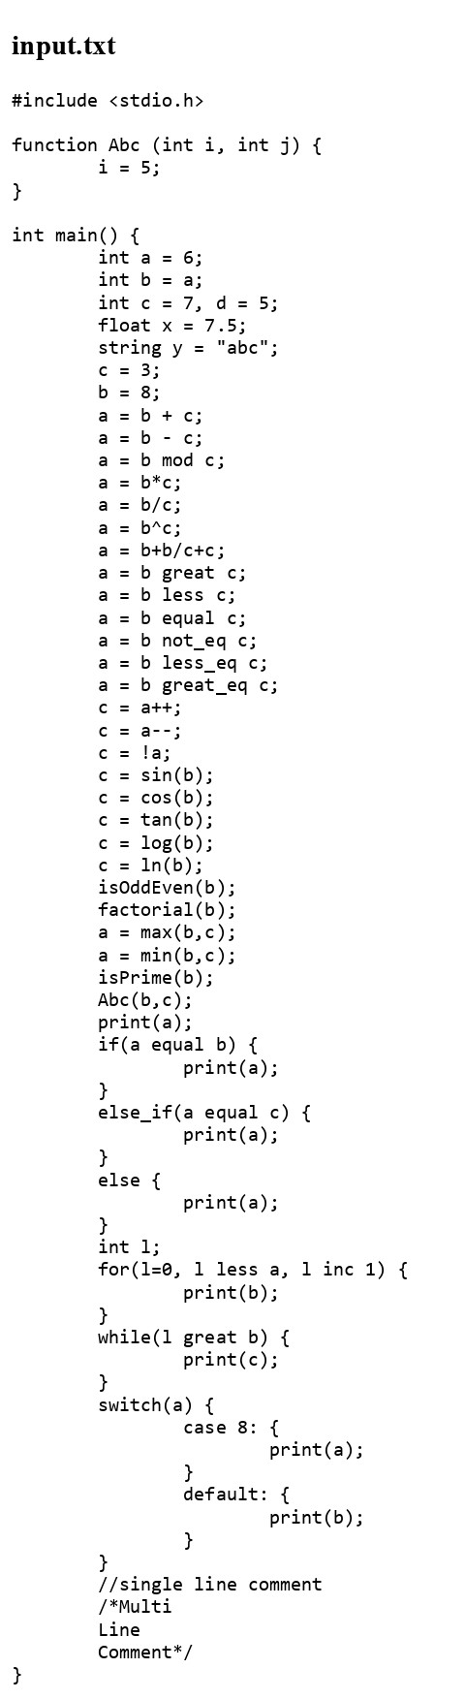

**Flex File:**

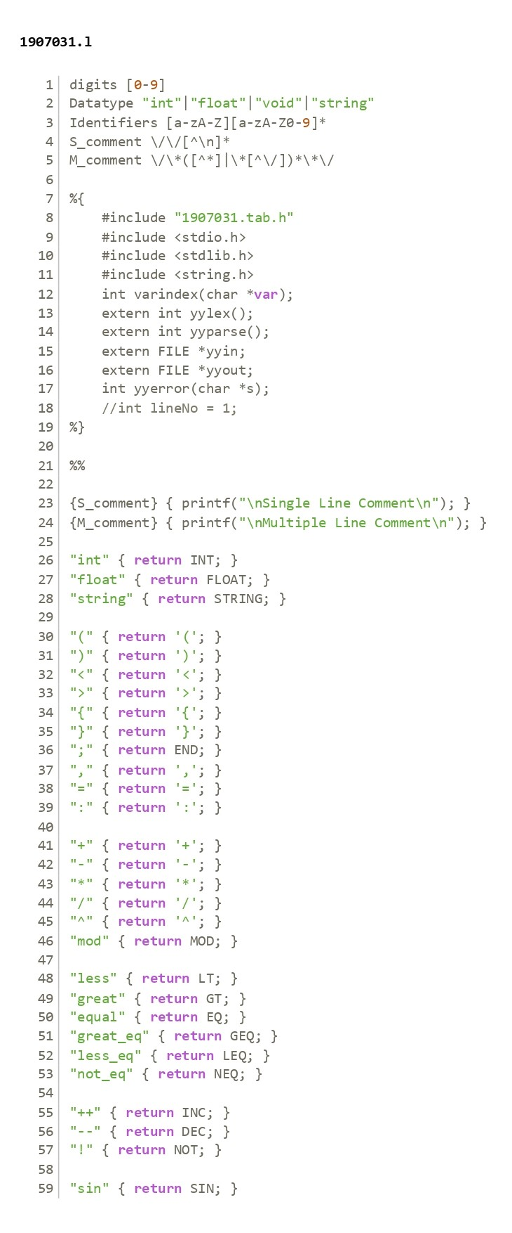

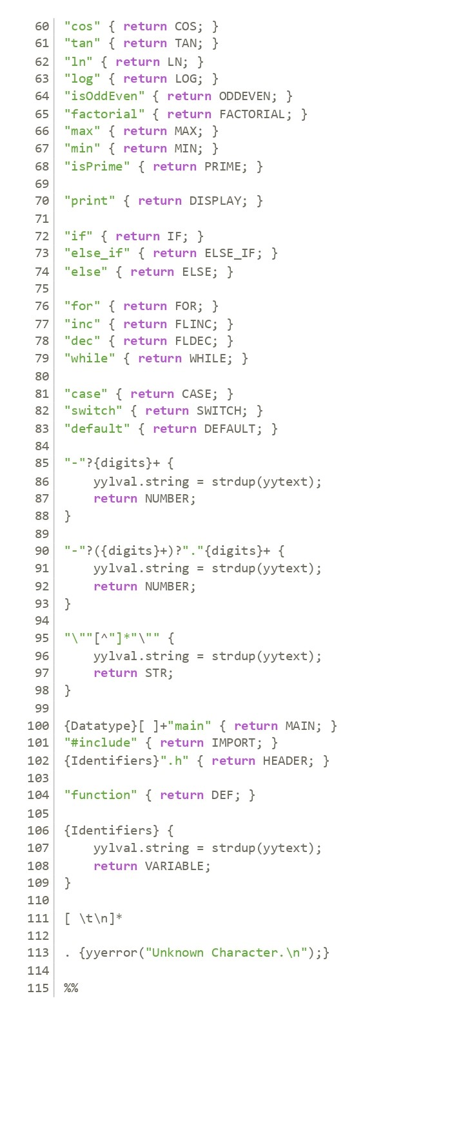

**Bison File:**

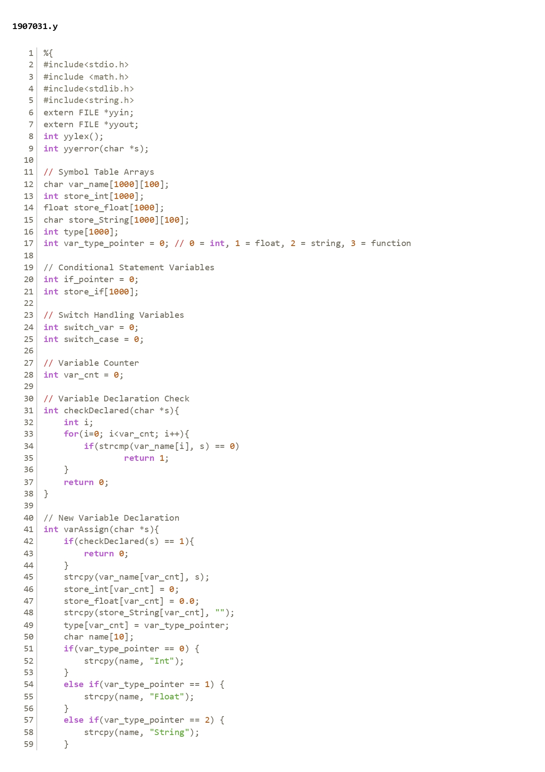

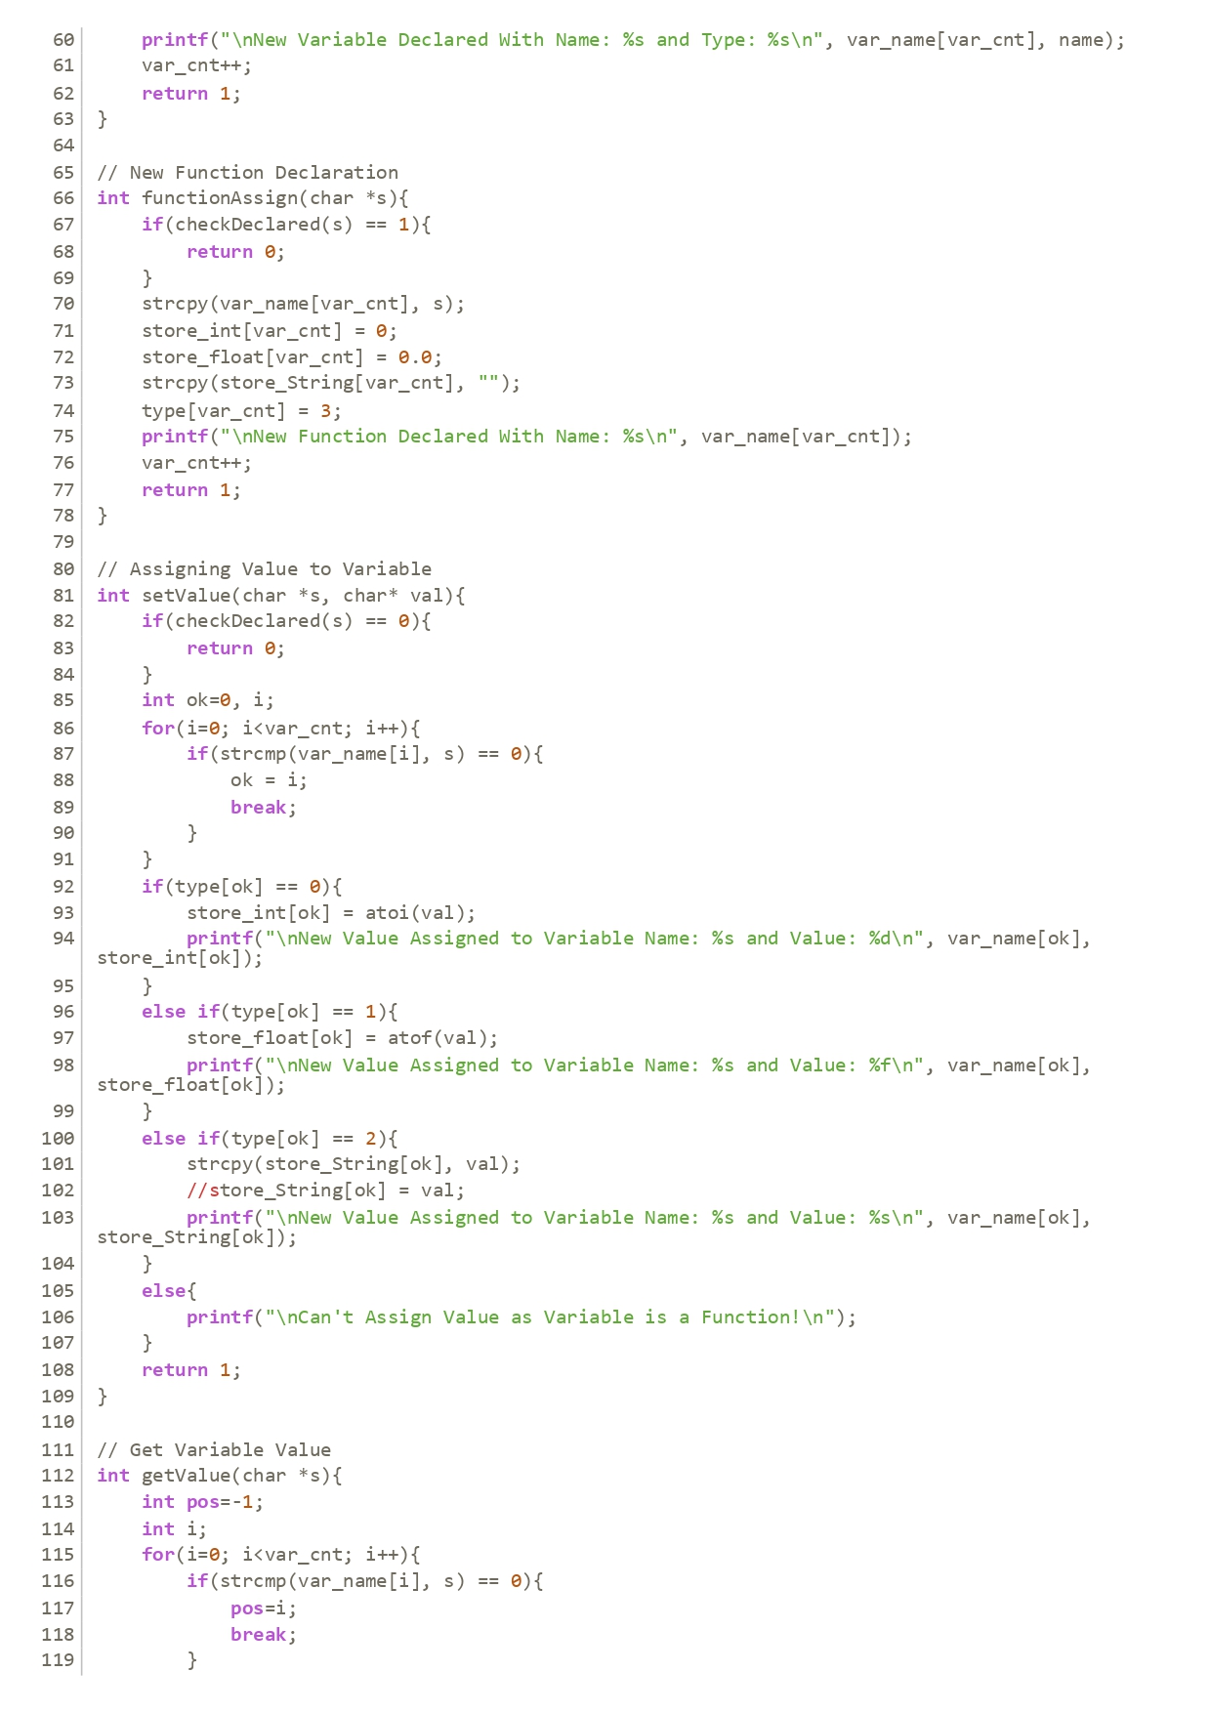

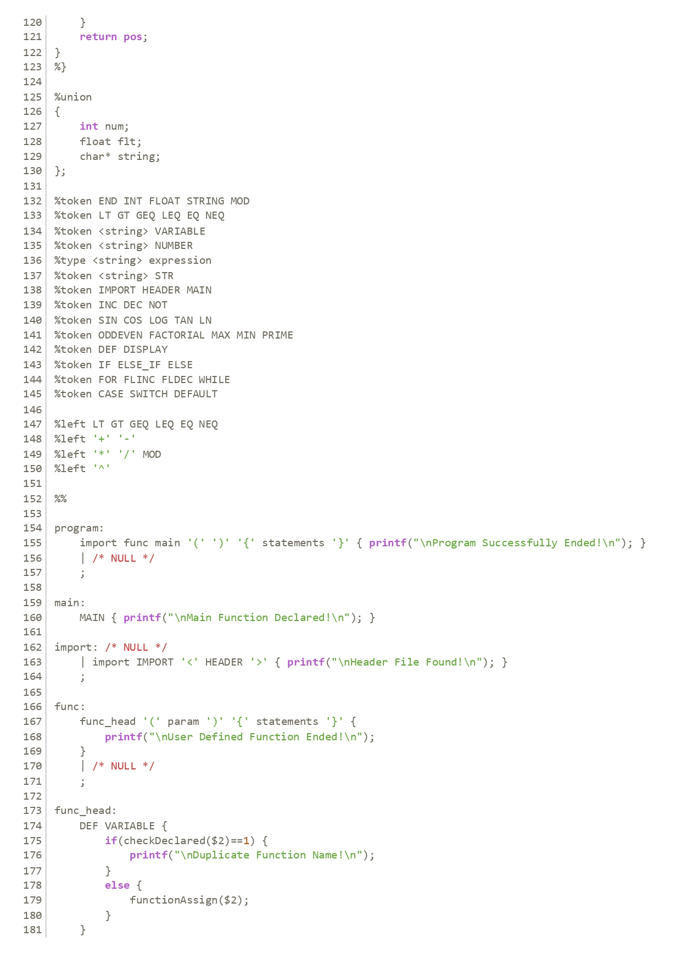

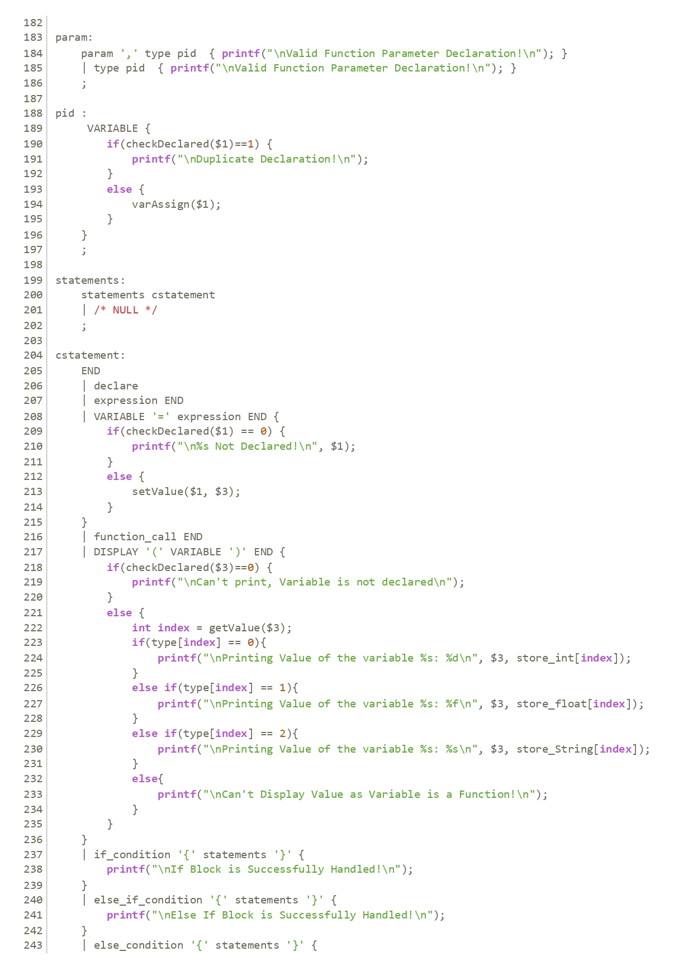

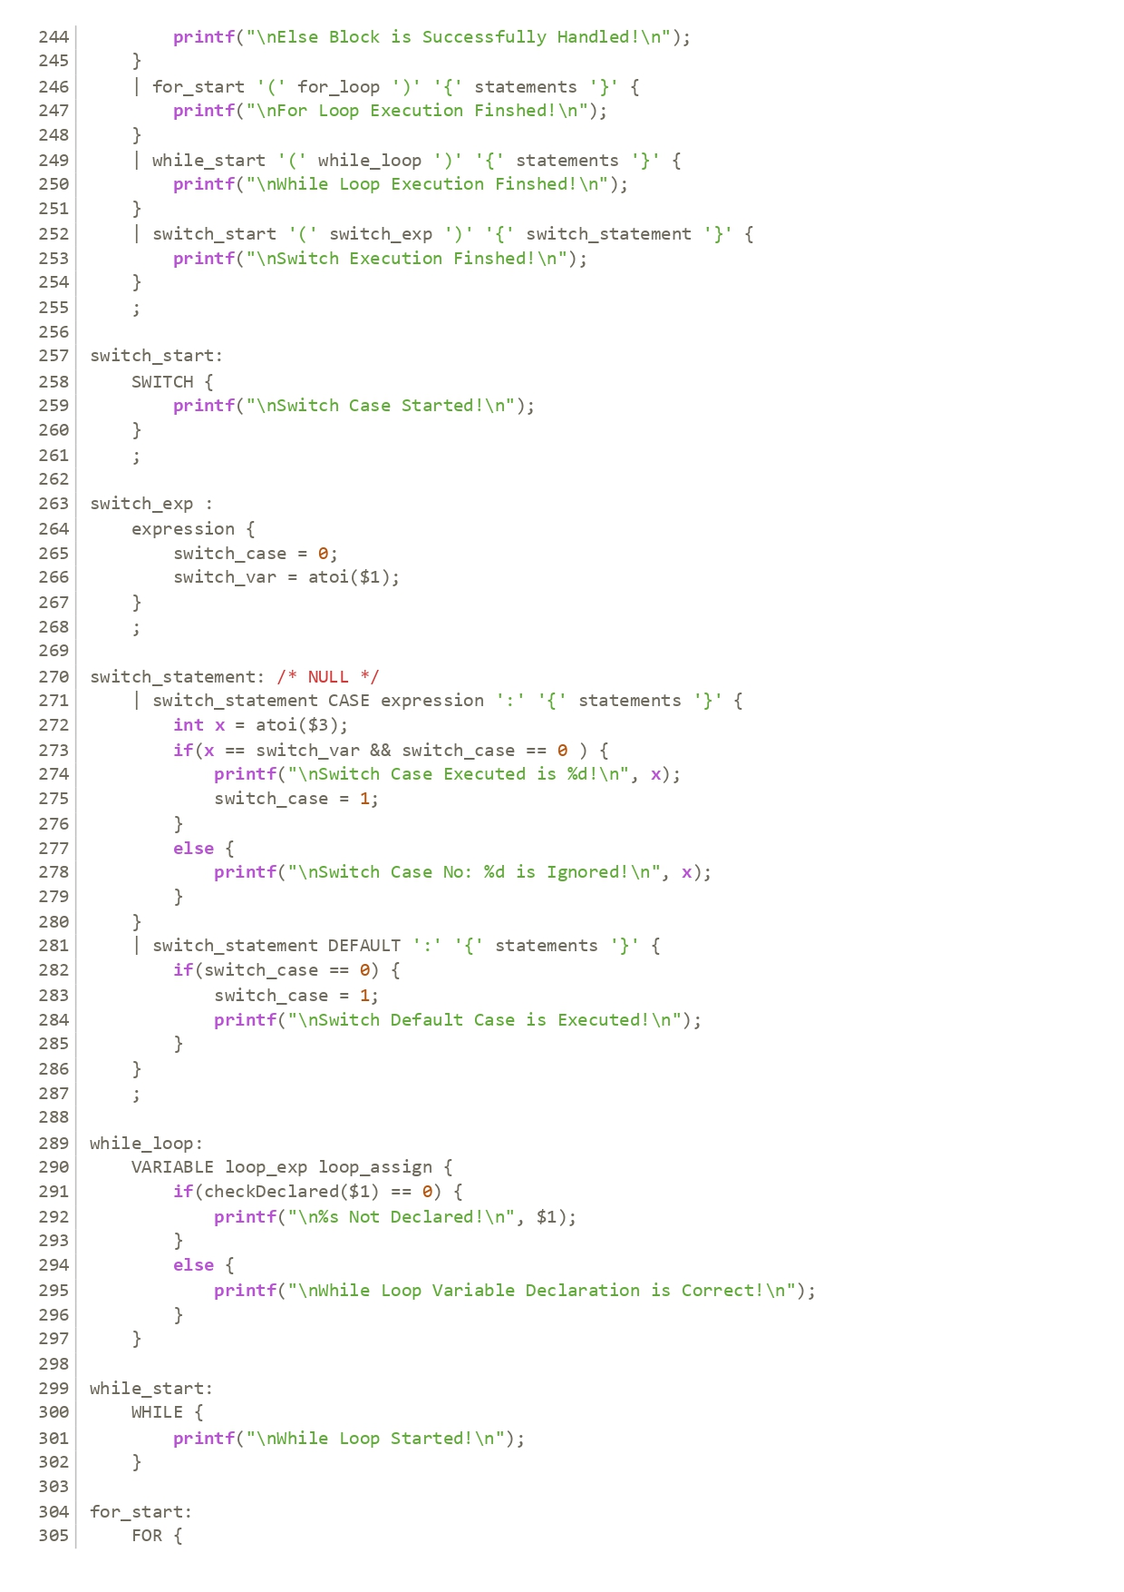

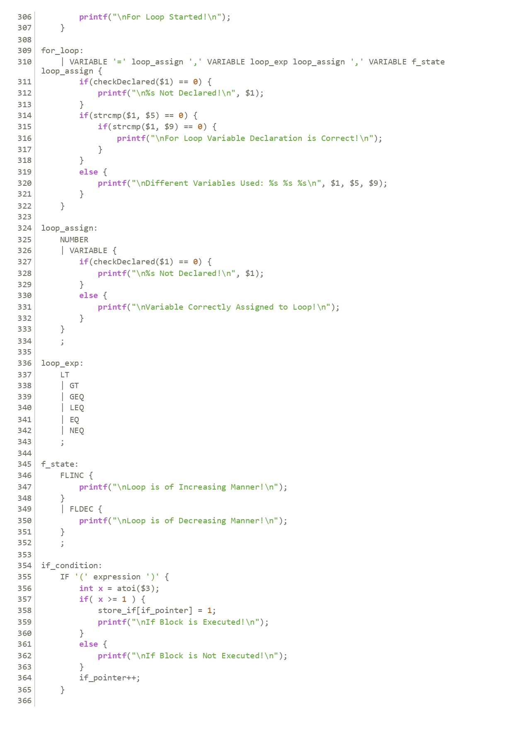

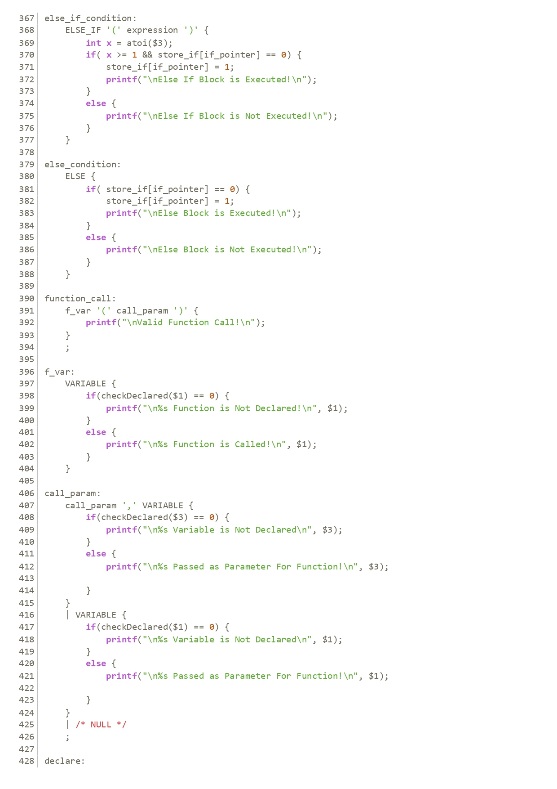

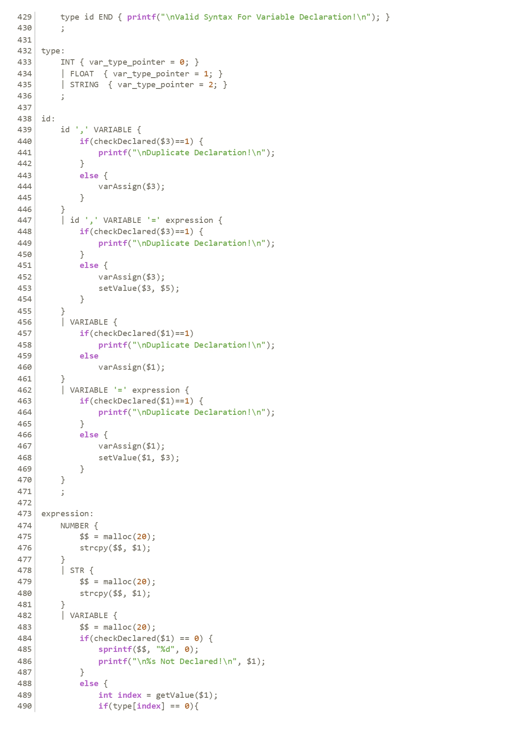

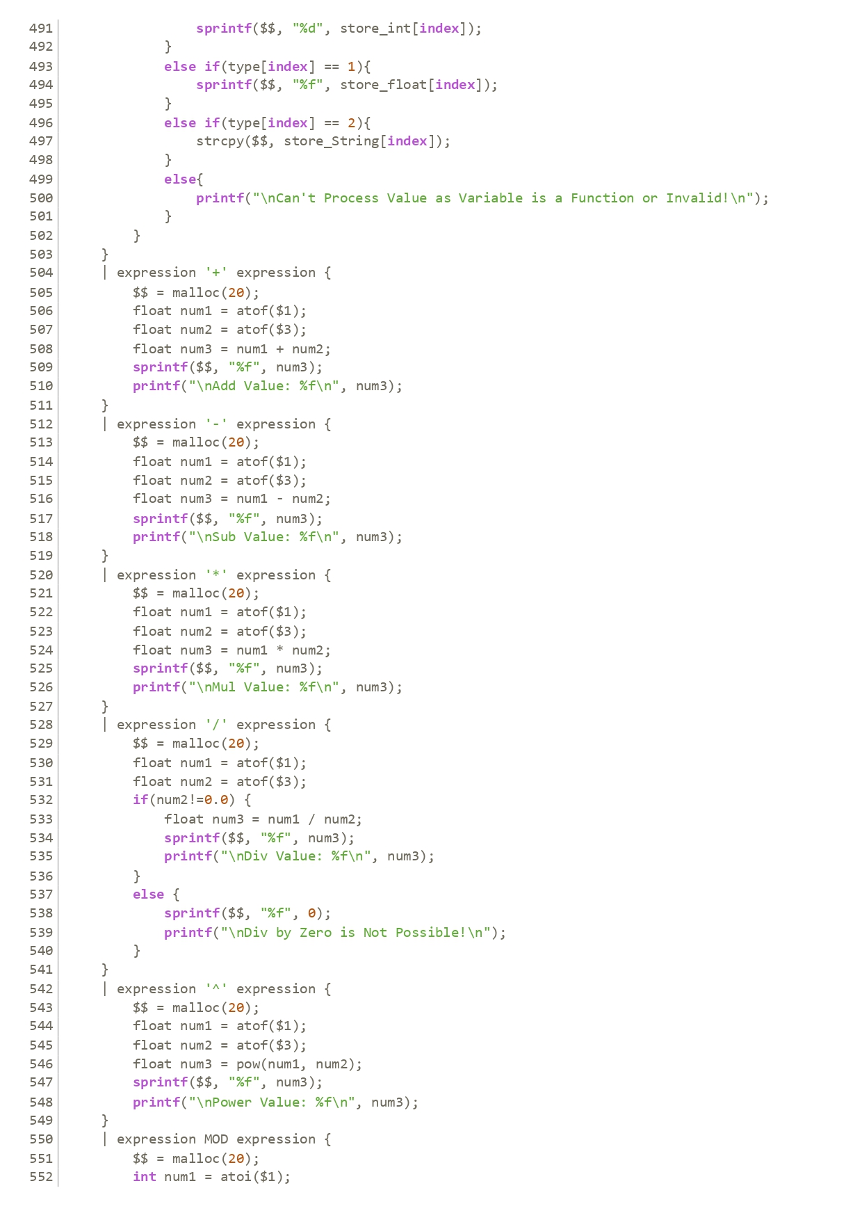

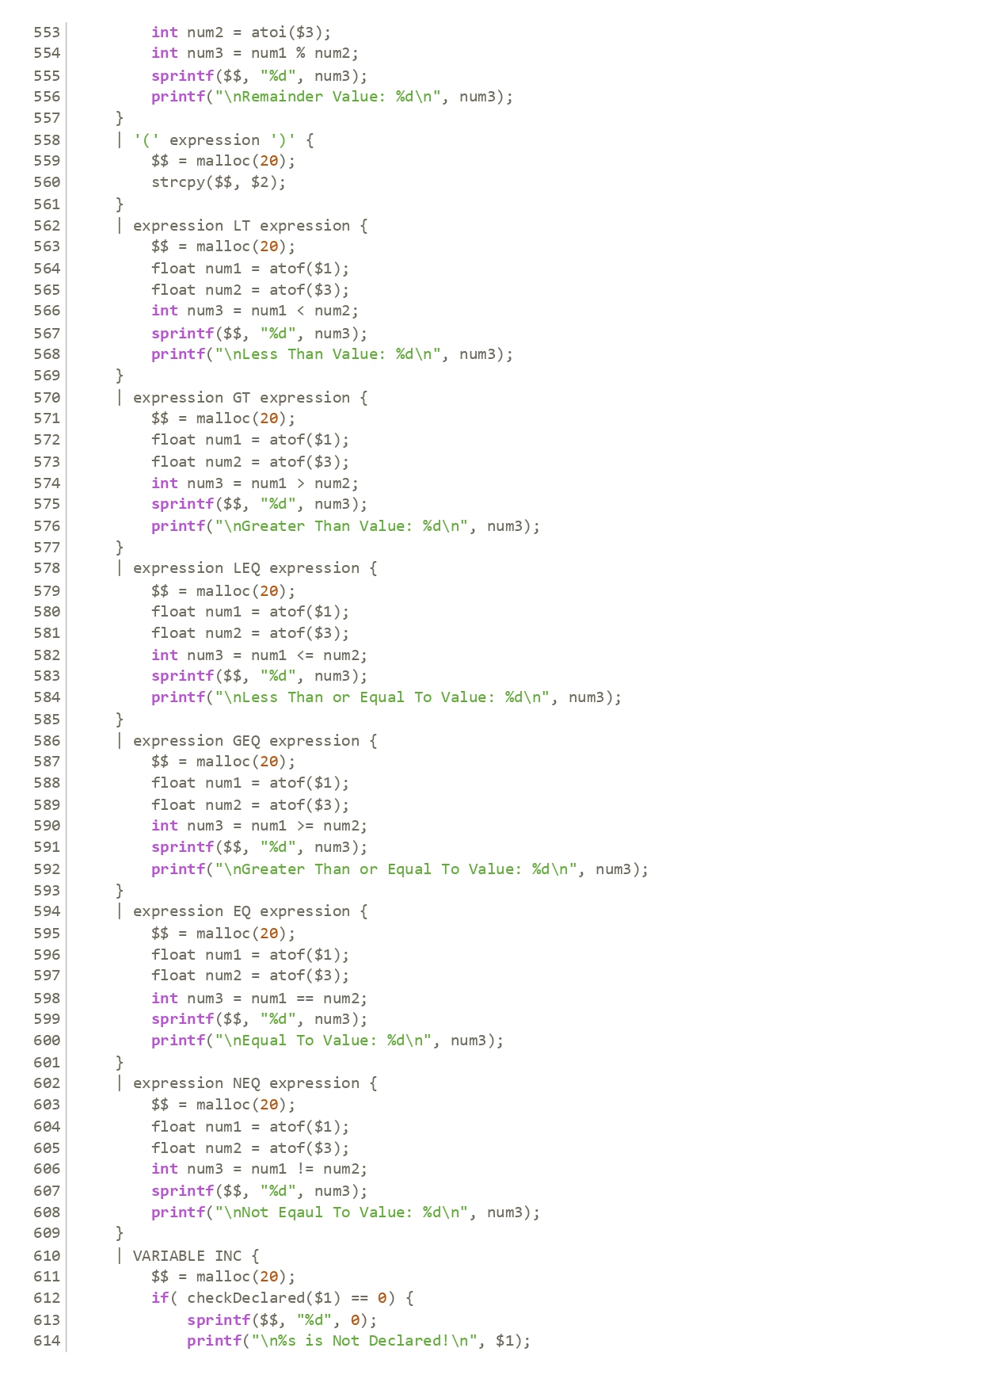

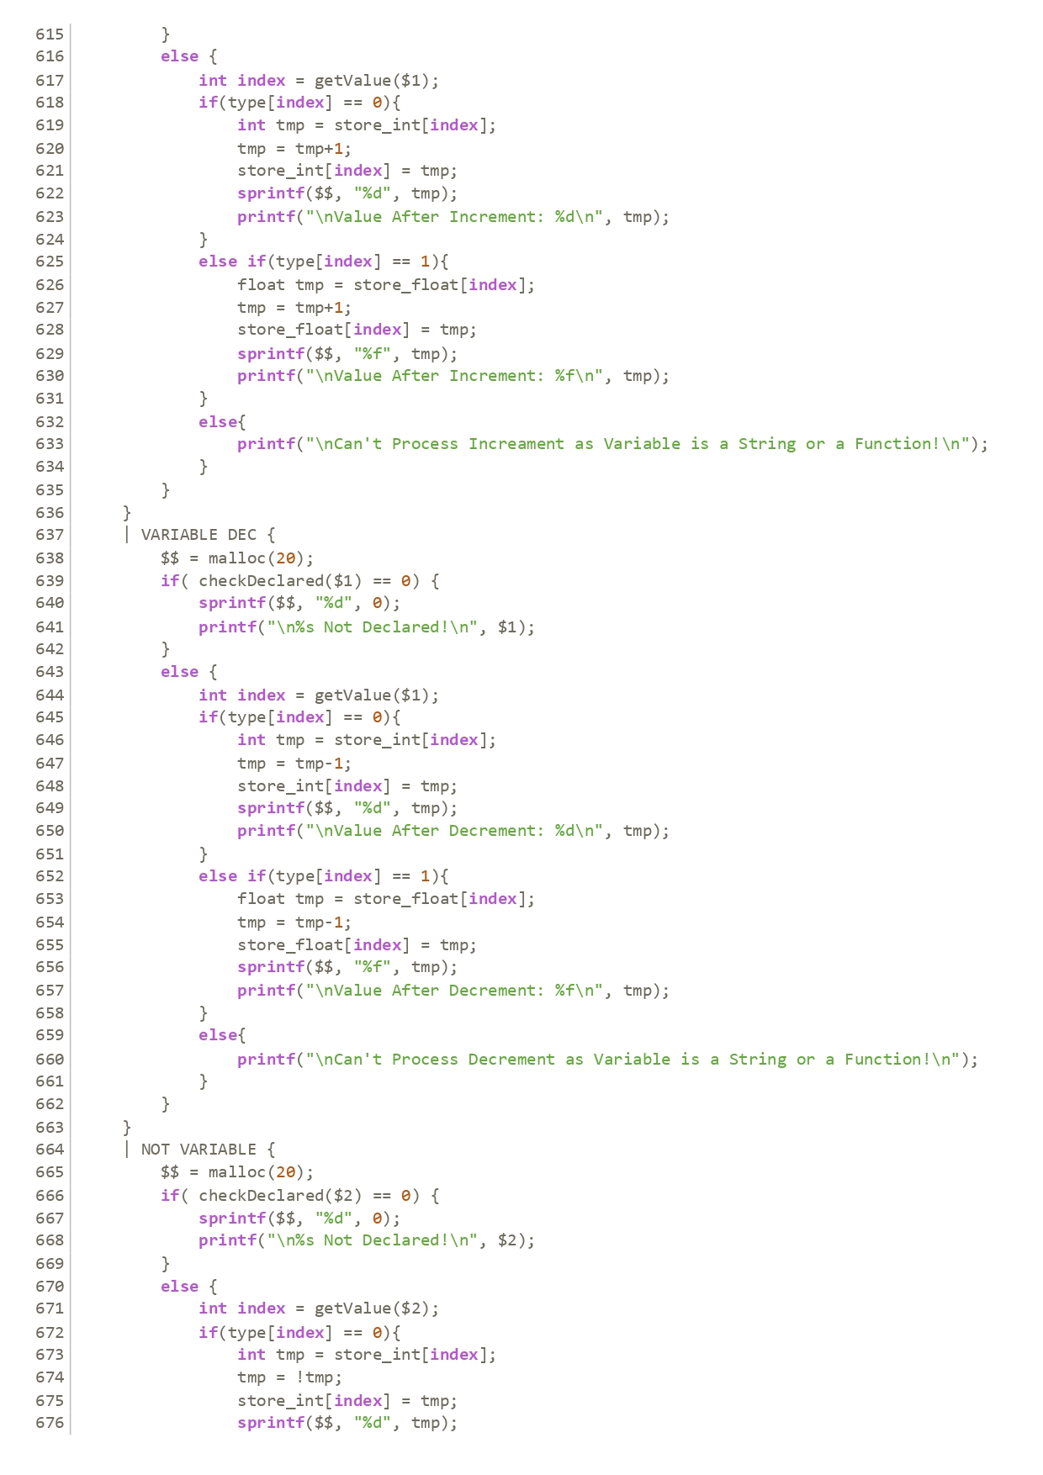

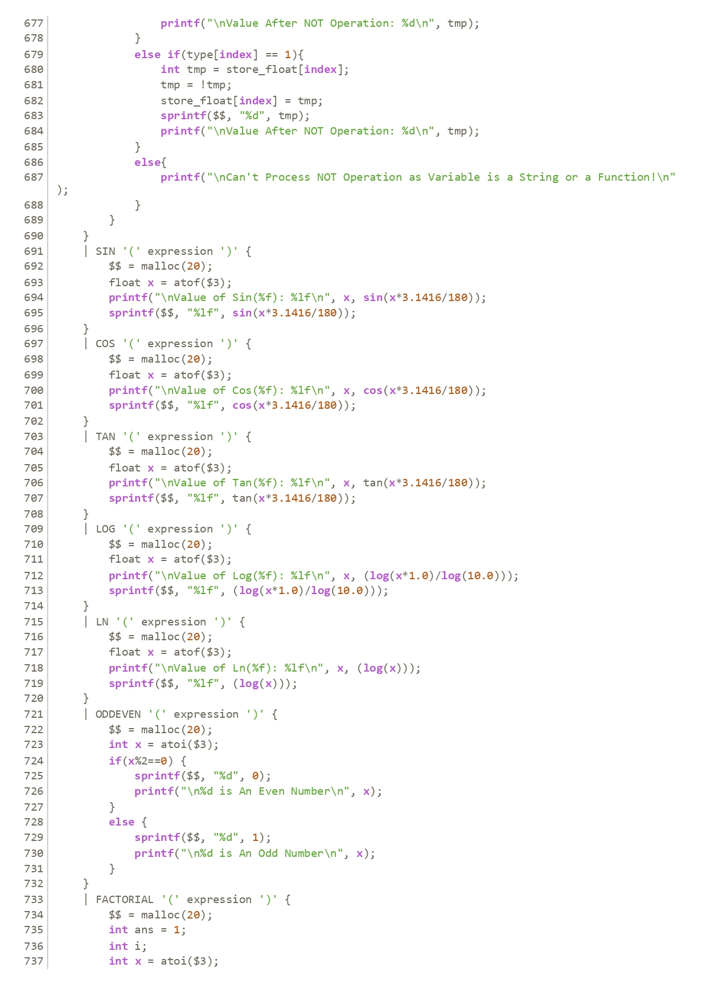

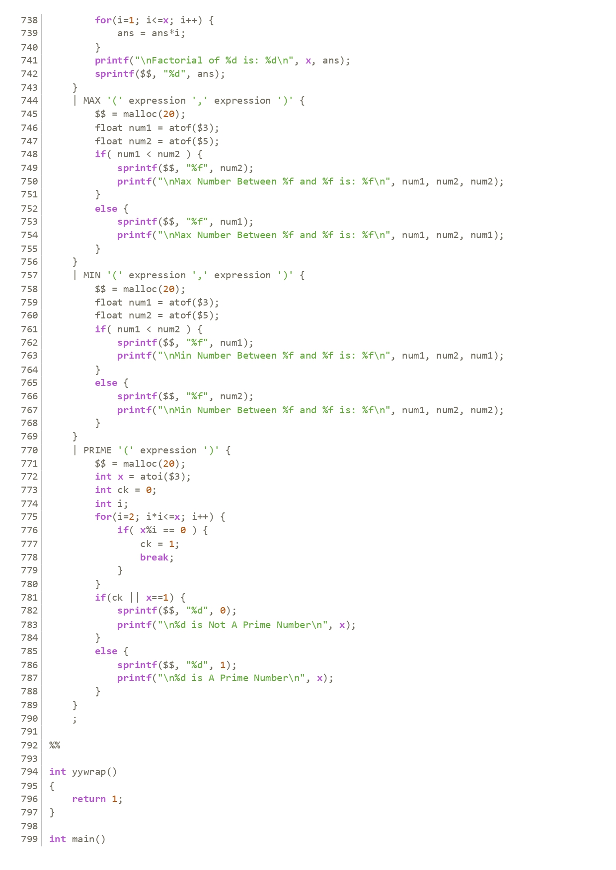

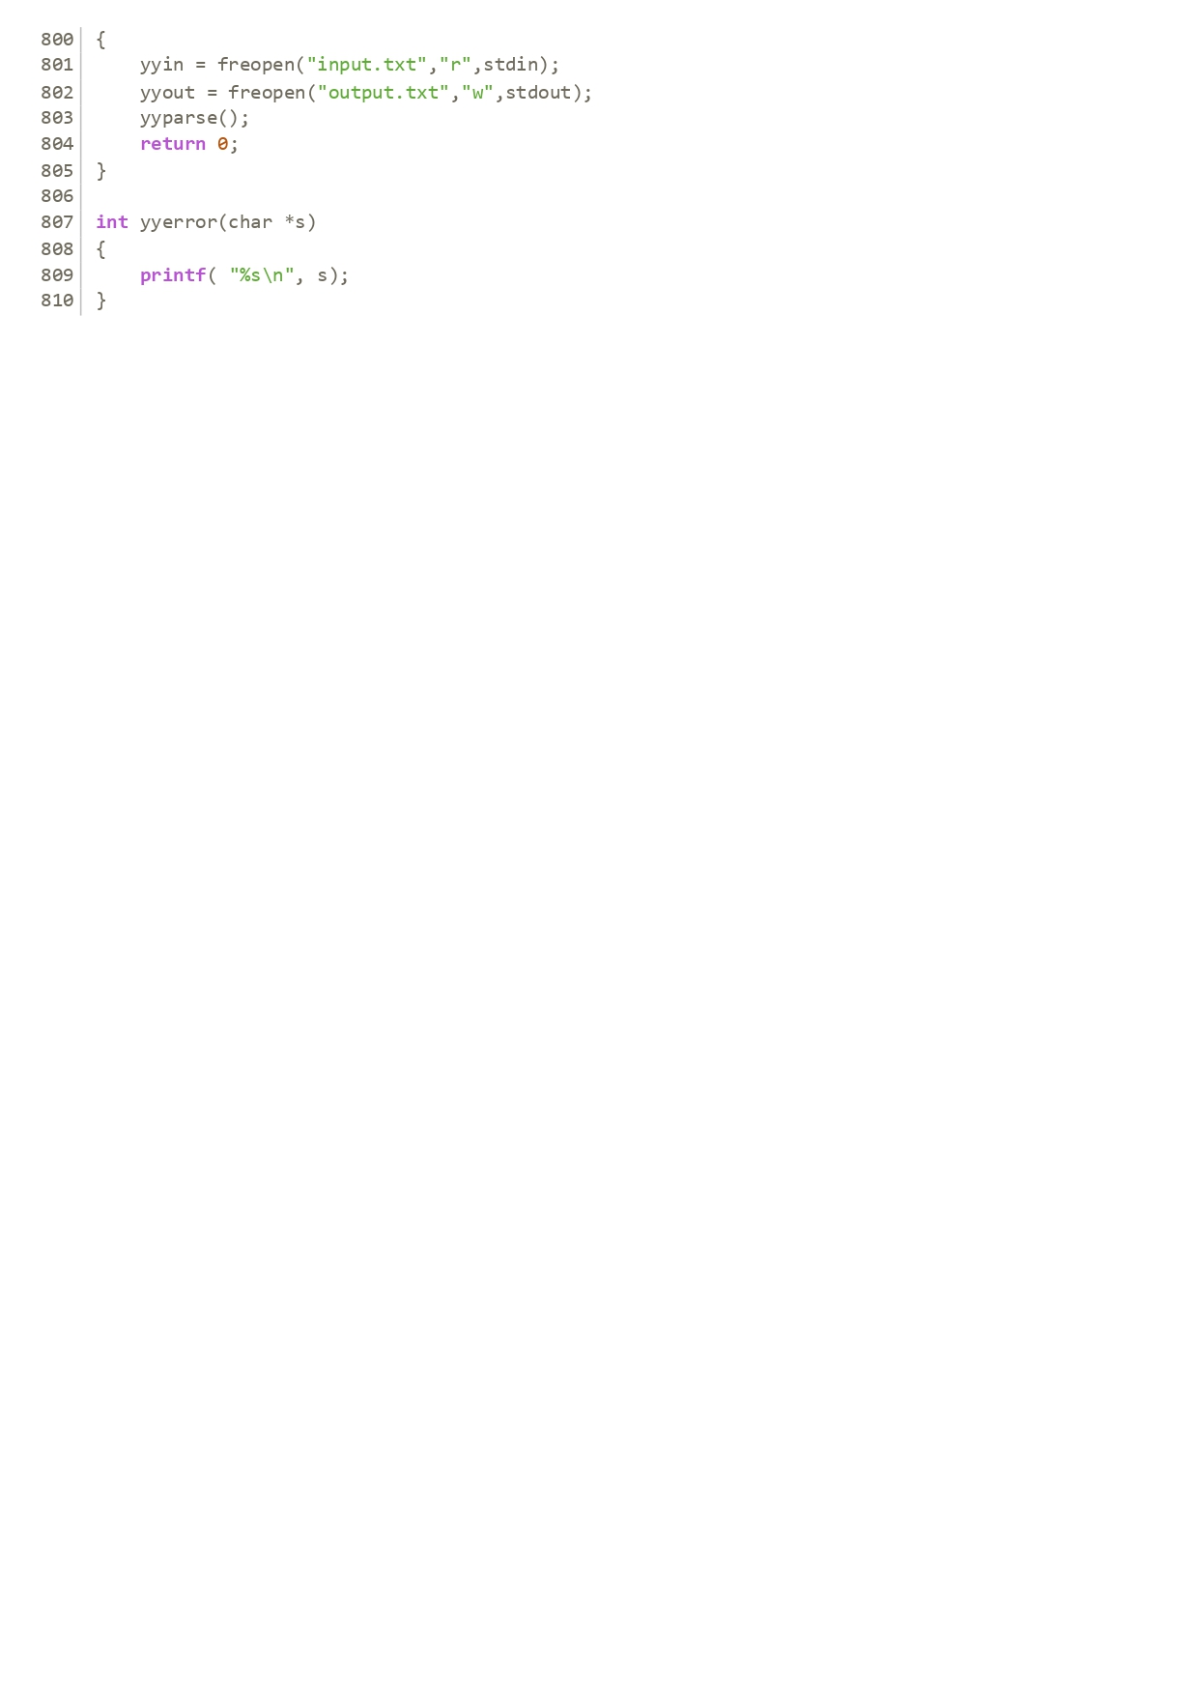

**Output File:**

‘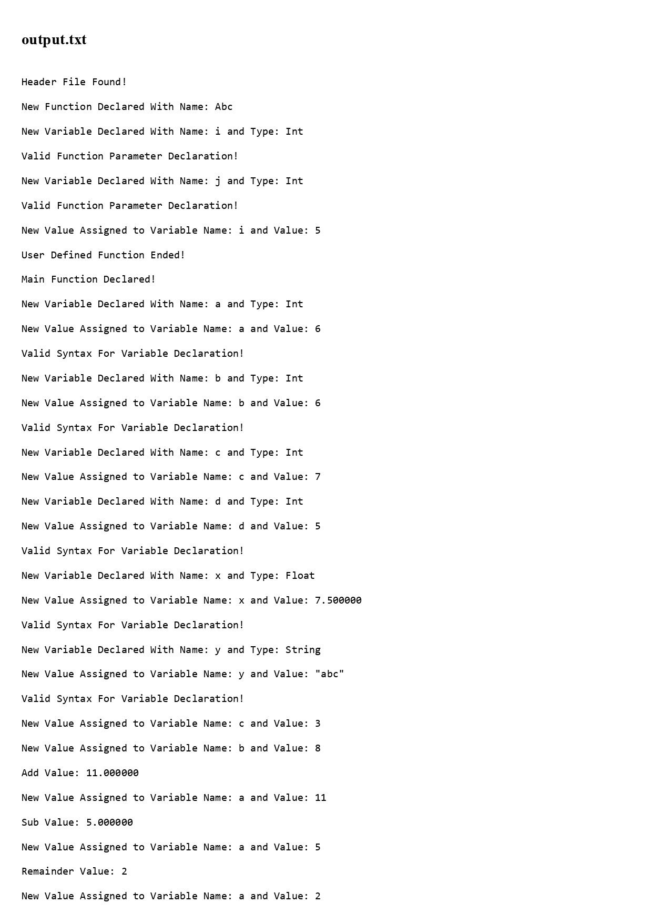

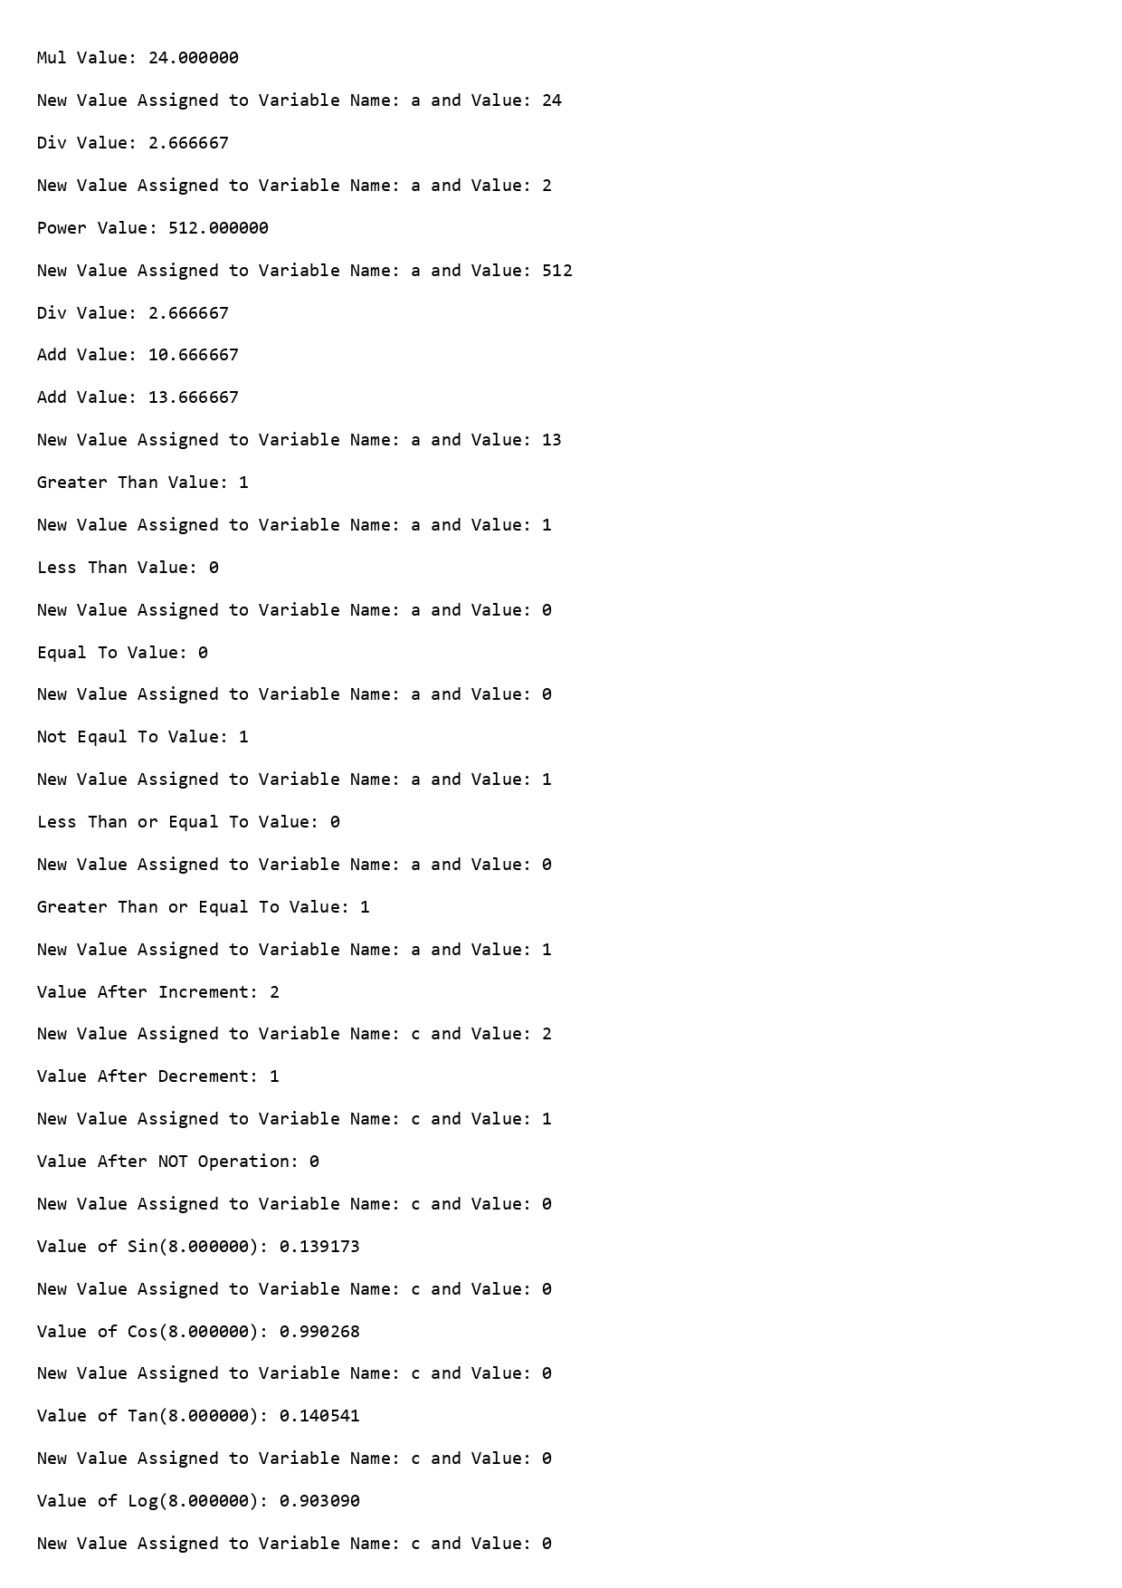

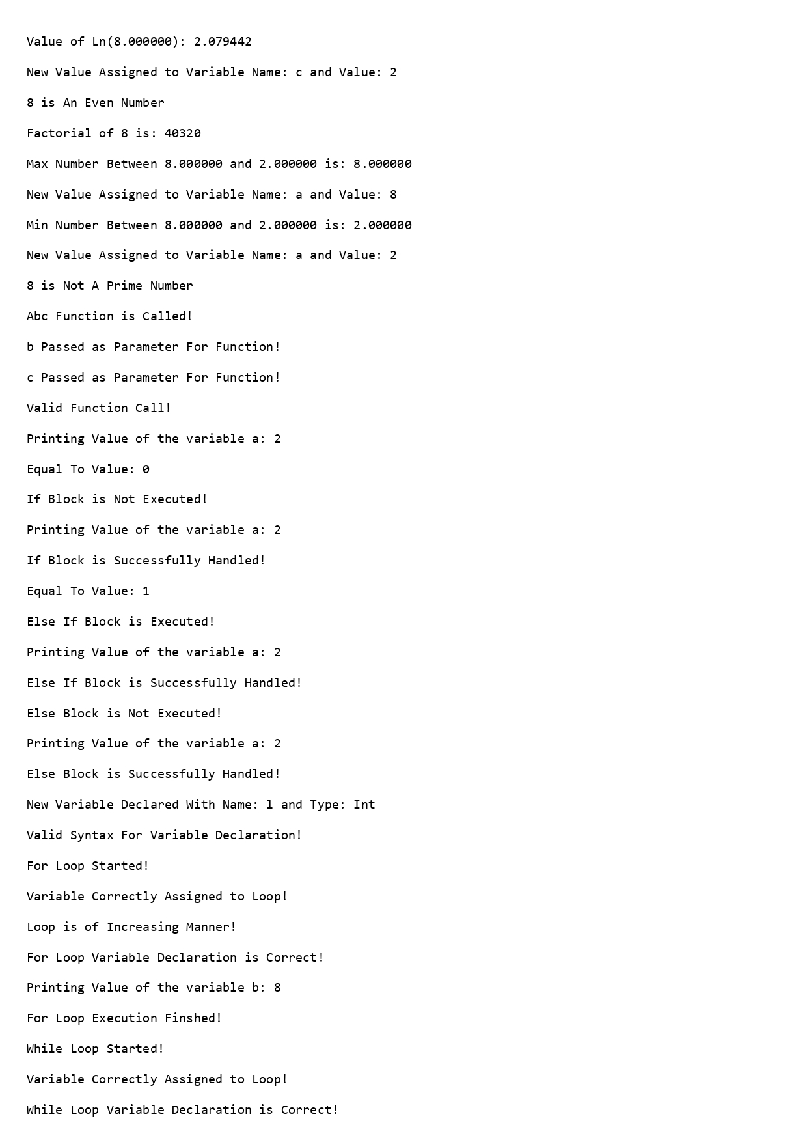

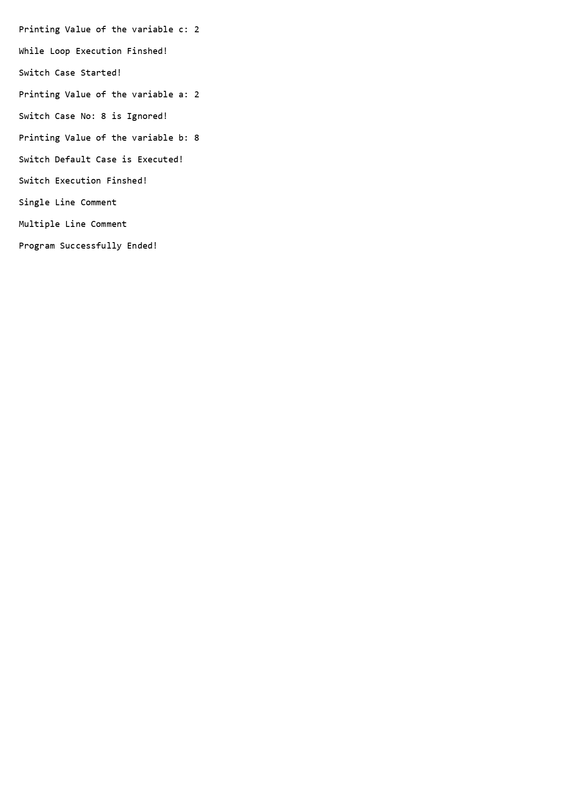

**Limitations:**

* Can’t handle operations involving Strings
* If/Else if/Else block statements execute regardless of it matched or not
* Switch Case block statements execute regardless of it matched or not
* Function call execution is not possible
* Loop statements do not actually loop
* User defined functions can only be declared before the main function
* Print function only prints variables
* Function parameter variables need to be unique and can’t be declared again in main function or any other statements
* Variable that has declared once can not be declared again regardless of the block it was declared in
* Most of the calculations are handled in float manner

**Discussion:**

The implementation of Flex and Bison in this project proved instrumental in achieving efficient lexical analysis and parsing. Flex's ability to generate rapid lexical analyzers streamlined the recognition of patterns within the input, while Bison facilitated the construction of a parser based on a well-defined context-free grammar. The integration of these tools showcased a seamless flow of control between the lexer and parser, enabling the comprehensive analysis of a new syntax-based programming language. Challenges encountered during testing were effectively addressed, leading to a robust language processing system. The results underscore the significance of Flex and Bison in the development of language processors, offering insights into their combined strength in handling complex parsing tasks.

**Conclusion:**

In conclusion, the integration of Flex and Bison in this project has demonstrated their pivotal role in efficient lexical analysis and parsing. Flex's swift pattern recognition, coupled with Bison's context-free grammar parsing capabilities, has yielded a robust language processing system. The successful handling of a new syntax-based programming language underscores the effectiveness of these tools in constructing language processors. As we reflect on the project, it is evident that Flex and Bison stand as indispensable assets in the development of parsers, offering a powerful tandem for tackling intricate syntax analysis tasks.

**Reference:**

* Lab Lectures
* Lab Codes
* Bison Manual - <https://www.gnu.org/software/bison/manual/bison.html>
* Flex Manual - <https://westes.github.io/flex/manual/>
* ChatGPT (Used for Debugging)